Internet Resources

MICRONESIAN ISLANDS
Commonwealth of the Northern Mariana Islands
Federated States of Micronesia
Republic of the Marshall Islands
Republic of Palau Islands
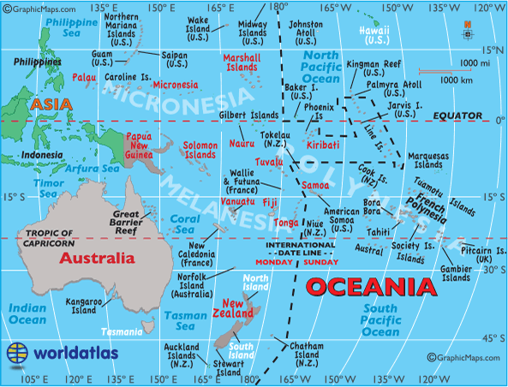
Guam, United States of America
World Map. (n.d.). Map of Australia & Oceania. Retrieved August 4, 2013 from http://www.worldatlas.com/webimage/countrys/.htm

GOVERNMENT

CIA
Marshall Islands
https://www.cia.gov/library/publications/the-world-factbook/geos/rm.html

Micronesia, Federated States of
https://www.cia.gov/library/publications/the-world-factbook/geos/fm.html

Palau
https://www.cia.gov/library/publications/the-world-factbook/geos/ps.html

Embassy of the Republic of the Marshall Islands
http://www.rmiembassyus.org/

Government of the Federated States of Micronesia
http://www.fsmgov.org/index.html
Kosrae State Legislature
http://kosraestatelegislature.webs.com/

Official website of Pohnpei state governor
http://www.pohnpeimet.fm/

Republic of Palau National Government
http://www.palaugov.net/

Yap State Government
http://www.yapstategov.org/default.html
Volume 1, Issue 1
World Map. (n.d.). Map of Australia & Oceania. Retrieved August 4, 2013 from http://www.worldatlas.com/webimage/countrys/.htm

ENCYCLOPEDIAS

Cengage Learning
http://www.highbeam.com/about-us

Encyclopedia.com
http://www.encyclopedia.com/

Information Please Database
Marshall Islands
http://www.infoplease.com/country/marshall-islands.html?pageno=4

Micronesia
http://www.infoplease.com/country/micronesia.html

MUSEUMS & CULTURAL CENTERS

Alele Museum, Library, and National Archives
http://alelemuseum.tripod.com/Index.html

Belau National Museum http://www.collectionsaustralia.net/pima/view_institution.php?inst_id=25
http://www.belaunationalmuseum.com

Etpison Museum and Gallery
Email: etpison@palaunet.com
http://www.collectionsaustralia.net/pima/view_institution.php?inst_id=24

FSM National Archives, Cultural and Historic Preservation Office
Email: hpo@mail.fm
http://www.collectionsaustralia.net/pima/view_institution.php?inst_id=53

Kosrae Historic Preservation Office
Email: ksa@mail.fm
http://www.collectionsaustralia.net/pima/view_institution.php?inst_id=28

Marshallese Cultural Center
Email: mcs-info@marshallese-cultural-center.org
http://www.collectionsaustralia.net/pima/view_institution.php?inst_id=29

Micronesia Area Research Center
http://www.uog.edu/marc/
http://www.collectionsaustralia.net/pima/view_institution.php?inst_id=38

Pacific heritage network
http://www.collectionsaustralia.net/pima/

Yap State Preservation Office
Email: yaphpo@mail.fm
http://www.collectionsaustralia.net/pima/view_institution.php?inst_id=14

LANGUAGES

Ethnologue: Languages of the World
http://www.ethnologue.com

TOURISM SERVICES

Federated States of Micronesia Visitors Board
http://www.visit-micronesia.fm/index.html

Kosrae Visitors Bureau
http://www.kosrae.com/

Marshall Islands visitor authority
http://www.visitmarshallislands.com/

Palau Visitor’s Authority
http://www.visit-palau.com/

Yap Visitors Bureau
http://www.visityap.com/index.html

National Geographic Society
Marshall Islands Guide
http://travel.nationalgeographic.com/travel/countries/marshall-islands-guide/

Micronesia Guide
http://travel.nationalgeographic.com/travel/countries/micronesia-guide/

Palau Guide
http://travel.nationalgeographic.com/travel/countries/palau-guide/

Traveler home
http://travel.nationalgeographic.com/travel/traveler-magazine/

OCEANS

Palau International Coral Reef Center & Palau Aquarium
http://www.picrc.org/index.php?option=com_content&view=category&layout=blog&id=51&Itemid=98

World’s Largest Shark Sanctuary
http://www.pewenvironment.org/news-room/press-releases/worlds-largest-shark-sanctuary-declared-in-central-pacific-85899364555

NEWS SERVICES

BBC News
Micronesia profile
http://www.bbc.co.uk/news/world-asia-pacific-15494620

Marshall Islands Profile
http://www.bbc.co.uk/news/world-asia-15595431

Palau Profile
http://www.bbc.co.uk/news/world-middle-east-15446659

FSM Telecommunications Corporation
http://www.fm/index.htm

Kaselehlie Press
http://www.kpress.info/

Pacific Magazine
http://www.pacificmagazine.net/

Pacific Islands News Association
http://www.pina.com.fj/index.php?p=pina&m=about-us

Palau National Communication Center
http://www.palaunet.com/homepage.aspx

The Marshall Islands Journal
http://www.marshallislandsjournal.com/index.html

NEWS ARTICLES

HONOLULU Magazine. (2011). Micronesian culture. HONOLULU Magazine. Retrieved July 31, 2013, from http://www.honolulumagazine.com/Honolulu-Magazine/August-2011/Micronesian-in-Hawaii/Micronesian-Culture/

Keany, M. (2011, August). Micronesian in Hawaii. HONOLULU Magazine: News & Opinion. Retrieved July 31, 2013, from http://www.honolulumagazine.com/Honolulu-Magazine/August-2011/Micronesian-in-Hawaii/index.php?cparticle=3&siarticle=2#artanc

REPORTS

Conroy, N. K. (2006). Study on the characteristics of Terminalia agroforestry in Kosrae island, Federated States of Micronesia (Thesis). University of Hawaii, Hawaii. Retrieved from http://scholarspace.manoa.hawaii.edu/bitstream/handle/10125/20761/M.S.Q111.H3_4052_r.pdf?sequence=2

OTHER

Cheifa Coins
http://www.chiefacoins.com/Database/index.htm

Countries and Territories
Marshall Islands
http://www.chiefacoins.com/Database/Countries/Marshall_Islands.htm

Palau
http://www.chiefacoins.com/Database/Countries/Palau.htm

Micro-Nations and Fantasy Worlds – Miscellaneous and Fantasy (Unofficial) Issues
Baker, Midway, and Wake Islands
http://chiefacoins.com/Database/Micro-Nations/Baker-Midway-Wake.htm

Federated States of Micronesia
http://chiefacoins.com/Database/Micro-Nations/Micronesia.htm

World Map. (n.d.). Map of Australia & Oceania. Retrieved August 4, 2013 from http://www.worldatlas.com/webimage/countrys/.htm
World Map. (n.d.). Map of Australia & Oceania. Retrieved August 4, 2013 from http://www.worldatlas.com/webimage/countrys/.htm
World Map. (n.d.). Map of Australia & Oceania. Retrieved August 4, 2013 from http://www.worldatlas.com/webimage/countrys/.htm

